- At quantum energies of photons, or correspondingly the kinetic energy of particles for radiation greater than 12 eV, the interaction of the radiation leads to ionization of atoms and molecules. In contrast to the photons of visible light which reversibly raise electrons into a higher excited state, in the case of ionizing radiation the electrons are fully ejected from the atomic orbitals. The results are on the one hand positively charged radicals, i.e., ions with an unpaired electron, and on the other hand free electrons. Both are short-living unstable products. As a consequence of this alteration, and as a result of the interaction of these primary products of radiolysis, even covalent chemical bonds could be broken.

- The entire biological effect starts with interference in a biological cascade of information transfer, i.e., with a DNA molecule or an important enzyme. This can either be the result of a direct interaction with the radiation quantum, or the consequence of an interaction with another product of radiolysis (indirect effect).

Free radicals are generated in great number by ionizing radiation due to the process of energy absorption and breakage of chemical bonds in molecules. These are known to play a major role in radiation effects on biological tissues and organisms. These radicals are highly reactive and found in a number of biological processes, metabolism, oxidation, reduction, and pathological diseases and cancer induction. Both electromagnetic and particulate radiations act on cells to cause free radicals and subsequent molecular damage through direct as well as indirect actions

- When ionizing radiation energy is deposited in a macromolecule that is important for the biological effect observed (often DNA for cell killing), it is called a direct effect of radiation. Alternatively, photons may be absorbed in the water of an organism causing excitation and ionization in the water molecules. The radicals formed after passage of radiation and water radiolysis, namely the hydrated electron (e_{aq}⁻), the hydrogen atom (H.) and the hydroxyl radical (.OH) contribute in causing damage to biological systems (indirect effect).

- Because water is by far the most common molecule in biological systems, its radiolysis products are of particular interest in the generation of indirect effects.
- In a first step within a time span of 10⁻¹⁸–10 ⁻¹⁶ s an electron is pulled out of the molecular binding, leaving a positively charged water radical (H₂O^{•+}), and a free electron.

- The released electron (e_{aq}) as a charge in an aqueous environment, immediately becomes hydrated, similar to ions in aqueous solutions.
- Because of this shell of bound water the life span of this free electron, depending on the pH of the solution, can achieve 600 s. It can interact with various other molecules. Reactions with other water molecules in the hydration shell are possible in the following way:
- e_{aq} + H₂O → H₂O⁻ → OH⁻ + H

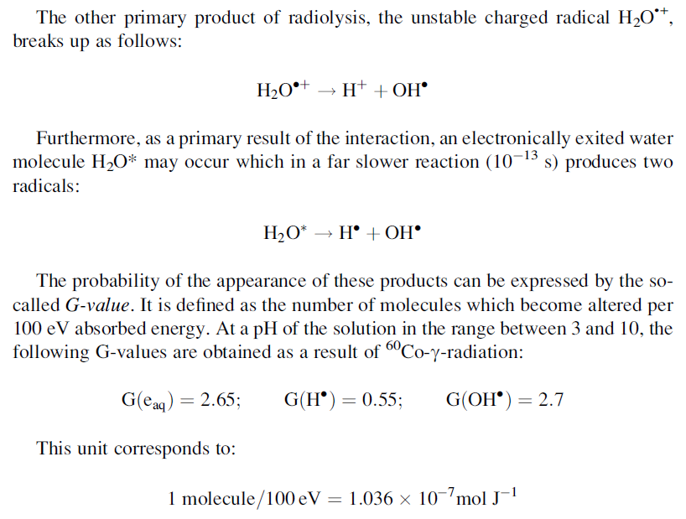

- It should be noted that these kinds of water radiolysis represent the third way to generate reactive radicals. First, the thermolysis of water was mentioned as the result of local heating through ultrasound cavitation. Secondly such radicals were explained as a result of UV-radiation, mediated by photosensitizers. These reactive species are together frequently summed up in the all-encompassing designation ROS (reactive oxygen species), all being highly reactive due to their content of unpaired valence electrons. This phrase, however, seems to be too imprecise because a greater diversity exists in reactive radicals involved in biological reactions, i.e., those that contain also nitrogen, sulfur, halogens, and carbon.

In fact, free radicals, especially the superoxide radical, are byproducts of the normal cellular metabolism. They are produced inside the mitochondria in the process of oxidative phosphorylation, by membrane-bound NADPH oxidase, or by the nitric oxide synthases. A number of enzymes such as superoxide dismutases, catalases, lactoperoxidases, glutathione peroxidases, or peroxiredoxins are able to regulate this concentration and defend the cells against damage. In fact, this is a complicated system of radical metabolism which by the way is also the subject of cancer research, and many other biomedical topics.
- Furthermore, there are a number of intercellular signaling pathways which are based on free radical processes, including ROS and similar species. This explains observations of the so-called bystander effect. In this case cells which have not been irradiated, nevertheless show radiation effects, caused by information transfer from irradiated neighboring cells.

In contrast to radicals occurring in normal metabolism, the particular effect of radical species produced by ionizing radiation is caused by the circumstance that they occur directly in the vicinity of biologically important molecules. This especially concerns DNA as a highly charged polyanion, strongly hydrated by water molecules. As a signature of DNA alterations through ionizing radiation, tandem lesions, or clusters of DNA lesions occur as the result of various radical-transfer reactions. This means that two or more defects are formed in close proximity on the same DNA strand or even double strand breaks. Even a single OH• radical is able to induce complex tandem lesions. Because this kind of DNA lesion is untypical in the endogenous processes the efficiency of the cellular repair mechanism is lower.
The hydrated electron reacts primarily with those parts of an organic molecule that have high affinity for electrons such as SH-, CO-, NO₂-, or NO-groups. Either it simply becomes attached to the molecule, thus imparting a negative charge to it, or a dissociative electron capture takes place which, similar to the instances described above, leads again to the formation of a free radical.

Cell defense systems
- In general, two cell defense systems must be considered to cope with free radical DNA damage. They work on very different time scales. On one hand there is a very fast chemical repair which occurs at the stage of DNA free radicals. This means that other molecules, so-called scavengers, like various thiols containing SH-groups transfer the electron by oxidation. On the other hand an enzymatic repair is possible which is slow, and active if the damage is fully settled. In this respect the double strand helix can be considered as a construction of higher stability against irradiation in relation to the single-stranded DNA helix. This is supported by experiments showing that if the hydrogen bridges between the two molecular filaments are broken by placing the DNA in a solution of urea, then the fragmentation of the DNA by irradiation becomes easier.

